

Darshan University

A Project Report on

**“Online Auction System”**

Under the subject

**Software Engineering (2101CS503)**

B. Tech, Semester – VI

Computer Science & Engineering Department

|  |  |
| --- | --- |
| Submitted By | |
| Student Name:Parmar Himanshu | Enrollment No.:22010101132 |
| Academic Year  (2023-2024) | |
| Internal Guide  Prof. Rajkumar B. Gondaliya Darshan University | Dean-DIET  Dr. Gopi Sanghani Darshan University |

|  |  |
| --- | --- |
|  | **Computer Science & Engineering Department**  **Darshan University** |

**DECLARATION**

We hereby declare that the SRS, submitted along with the **Software Engineering (2101CS503)** for entitled **“Online Auction System”** submitted in partial fulfilment for the Semester-5 of **Bachelor Technology (B. Tech)** in **Computer Science and Engineering (CSE)** Department to Darshan University, Rajkot, is a record of the work carried out at **Darshan University, Rajkot** under the supervision of Rajkumar B. Gondaliya and that no part of any of report has been directly copied from any students’ reports, without providing due reference.

Parmar Himanshu

Student’s Signature

Date:

|  |  |
| --- | --- |
|  | **Computer Science & Engineering Department**  **Darshan University** |

**CERTIFICATE**

This is to certify that the SRS on **“Online Auction System”** has been satisfactorily prepared by **Parmar Himanshu** (**22010101132**) under my guidance in the fulfillment of the course **Software Engineering (2101CS503)** work during the academic year 2023-2024.

|  |  |
| --- | --- |
| Internal Guide  Prof. Rajkumar B. Gondaliya  Darshan University | Dean-DIET Dr. Gopi Sanghani Darshan University |

**ACKNOWLEDGEMENT**

I wish to express my sincere gratitude to my project guide Prof. **Rajkumar B. Gondaliya** and all the faculty members for helping me through my project by giving me the necessary suggestions and advices along with their valuable co-ordination in completing this work.

I also thank my parents, friends and all the members of the family for their precious support and encouragement which they had provided in completion of my work. In addition to that, I would also like to mention the Darshan University personals who gave me the permission to use and experience the valuable resources required for the project from the University premises.

Thus, in conclusion to the above said, I once again thank the faculties and members of

**Darshan University** for their valuable support in completion of the project.

Thanking You

**Parmar Himanshu**

**ABSTRACT**

The Online Auction System is a comprehensive, digital platform designed to facilitate the buying and selling of items through competitive bidding. This system transforms traditional auction processes into an efficient, user-friendly online experience. It incorporates features such as user registration and login, item listing, bidding, and real-time auction updates. Sellers can easily list items for auction, providing detailed descriptions, images, and starting prices. Buyers can browse available items, place bids, and receive notifications about their bid status.

The system includes an admin panel that allows administrators to manage users, monitor auctions, and generate various reports, such as user activity reports, auction statistics, and financial summaries. Key functionalities include the ability to search for items, view bid history, and utilize 'Buy Now' options for immediate purchases.

The primary objective of this system is to streamline the auction process, making it more efficient and accessible, while minimizing human intervention and errors. By leveraging modern web technologies, this system ensures a seamless and engaging experience for all users involved in online auctions.

**Table of Contents**

List of Figures I

List of Tables II

1. Introduction 1
   1. Product perspective 1
   2. Product features 1
      1. There are three different users who will be using this product: 1
      2. The features that are required for the Administrator are: 1
      3. The features that are required for the Vendor are: 1
      4. The features that are required for the Customer are 1
   3. Functional Requirement 2
      1. Administrator 2
      2. Vendor 2
      3. Buyer 3
      4. Guest 3
   4. Non-Functional Requirement 3
      1. Performance 3
      2. Usability 3
      3. Security 4
      4. Monitoring and Reporting 4
2. Design and Implementation Constraints 5
   1. Use case diagram 5
   2. Activity diagram and Swimlane diagram 7
   3. Sequence diagram 9
   4. State diagram 10
   5. Class diagram 11
   6. Data flow diagram 12
      1. Context diagram (level-0) 12
      2. DFD Level-1 12
3. External interface requirement (Screens) 13
   1. Screen-1: Home screen 13
   2. Screen-2: Auction Item List 14
   3. Screen-3: Item details 15
   4. Screen-4: Store List 16
   5. Screen-5: Categories Grid 17
4. Database design 18
   1. List of Tables 18
5. Stories and Scenario 20
   1. Story-1: Create New Auction Listing 20
      1. Scenario# S1.1 20
      2. Scenario# S1.2 20
      3. Scenario# S1.3 20
   2. Story-2: Search for Auctions 21
   3. Story-3: Place a Bid 21
   4. Story-4: Manage Auction End Date 21
   5. Story-5: Generate a Report on Auction Activity 21
6. Test cases 22
7. References 27

# List of Figures

Figure 2.1-1 Use case diagram for Online Auction System 5

Figure 2.1-2 Use case diagram for Online Auction System 7

Figure 2.2-1 Activity diagram for Register 7

Figure 2.2-2 Swimlane diagram for Auction Start 8

Figure 2.3-1 Sequence diagram for Create Item 9

Figure 2.4-1 State diagram Auction Start 10

Figure 2.4-2 State diagram for Auction Bidding 10

Figure 2.5-1 Class diagram for Online Auction System 11

Figure 2.6-1 Context diagram for Online Auction System 12

Figure 2.6-2 DFD level-1 for Online Aution System 12

Figure 3.1-1 Screen-1: Home Screen 13

Figure 3.2-1 Screen-2: Auction item list 14

Figure 3.3-1 Screen-3: Item details 15

Figure 3.4-1 Screen-4:Store List 16

Figure 3.4-1 Screen-5:Categories grid 17

# List of Tables

Table 3.1-1 Screen element of Home Screen 13

Table 3.2-1 Screen element of Item List 14

Table 3.3-1 Screen element of Item Details 15

Table 3.4-1 Screen element of Store List 16

Table 3.4-1 Screen element of Categories grid 17

Table 4.1-1 Table: Users 18

Table 4.1-2 Table: Item 18

Table 4.1-3 Table: Bids 18

Table 4.1-4 Table: Categories 18

Table 4.1-5 Table: Payments 19

# Introduction

## Product perspective

Welcome to the "Online Auction System." This innovative platform revolutionizes the auction process by enabling seamless online bidding and product sales. Vendors can easily list their products for auction, and customers can place competitive bids to purchase them. The main objective of the e-Auction process is to obtain the best value and the highest price for products. Achieving optimal outcomes requires focusing on overall value rather than just price alone. The "Online Auction System" caters to two main user categories: customers and vendors. Vendors can sell their products on the website, and customers can participate in the auctions by placing bids. The product will be sold to the customer who places the highest bid. Users can place multiple bids on various products, ensuring a dynamic and competitive bidding environment.

## Product features

### There are three different users who will be using this product:

* + - * Addministrator who will manage the overall platform.
      * Vendor who will be listing products for auction.
      * Customer who will be placing bids on products.

### The features that are required for the Administrator are:

* + - * Control and manage vendor and customer accounts.
      * Oversee the listing and movement of products and ensure proper documentation.
      * Monitor ongoing auctions to ensure fair play and compliance with platform rules.
      * Search for specific products or users based on various criteria such as name, category, or user details.
      * Generate reports on auction activities, sales, and user engagement.
      * Address and resolve any disputes between vendors and customers.
      * Perform regular maintenance tasks to keep the platform running smoothly.
      * Send notifications and updates to users about their activities and auction statuses.

### The features that are required for the Vendor are:

* + - * Add and manage products for auction with detailed descriptions and images.
      * Set auction parameters such as start time, end time, and minimum bid increments.
      * View and manage bids placed on their products.
      * Access reports on sales and bidding history for their products.
      * Communicate with customers through the platform regarding their products and auctions.
      * Manage their account details, payment information, and transaction history.

### The features that are required for the Customer are:

* + - * View and browse different categories of products available for auction.
      * Place bids on products they are interested in purchasing.
      * Create and manage their account details and personal information.
      * Track their bids and receive notifications about the status of their bids.
      * View their purchase history and transaction details.
      * Search for specific products based on keywords, categories, or vendors.
      * Provide feedback and reviews on products they have purchased.

## Functional Requirement

* Users of this System:
  1. **Administrator**: Manages and oversees the platform or system, handling tasks like user management, content moderation, and system maintenance.
  2. **Vendor (Seller)**: A person or business that offers goods or services for sale on a platform or marketplace.
  3. **Customer (Buyer)**: An individual or entity purchasing goods or services from a vendor or business.
  4. **Guest**: A visitor with limited access, often browsing without full user privileges or registration.

### Administrator

* + - * User Management: The system shall allow the Administrator to create, update, and delete user accounts.
      * Role Assignment: The system shall allow the Administrator to assign roles (buyer, seller, admin) to users.
      * Auction Monitoring: The system shall provide the Administrator with the ability to monitor active, upcoming, and completed auctions.
      * Dispute Resolution**:** The system shall enable the Administrator to intervene and resolve disputes between buyers and sellers.
      * Content Moderation**:** The system shall allow the Administrator to review and approve or reject auction listings before they go live.
      * Policy Enforcement: The system shall enable the Administrator to enforce site policies and rules by banning or suspending users who violate terms of service.
      * Reporting and Analytics: The system shall provide the Administrator with detailed reports and analytics on system usage, auction activities, and financial transactions.
      * System Configuration: The system shall allow the Administrator to configure system settings such as auction duration, bid increments, and notification preferences.
      * Security Management: The system shall enable the Administrator to manage security settings, including setting password policies and enabling/disabling two-factor authentication.
      * Payment Management: The system shall allow the Administrator to oversee and manage payment gateways, transaction fees, and financial reconciliations.
      * Data Backup and Recovery: The system shall allow the Administrator to perform data backups and manage data recovery processes.
      * Communication Management: The system shall enable the Administrator to send messages or notifications to all users or specific user groups.

### Vendor

* + - * Item Listing Creation: The system shall allow sellers to create new auction listings by providing item details, descriptions, images, starting price, and auction duration.
      * Item Listing Management: The system shall allow sellers to edit or delete their auction listings before any bids are placed.
      * Reserve Price Setting: The system shall allow sellers to set a reserve price for their auction listings to ensure the item is not sold below a certain amount.
      * Bid Management: The system shall notify sellers when new bids are placed on their auction listings.
      * Communication with Buyers: The system shall allow sellers to communicate with potential buyers via a messaging system.
      * Payment Processing: The system shall facilitate the processing of payments from buyers to sellers once an auction is completed.
      * Feedback Management: The system shall allow sellers to leave feedback for buyers based on their transaction experience.
      * Upload Images: The seller must be able to upload multiple images for each auction listing to provide visual representation of the item.
      * View Active Auctions: The seller must be able to view a list of their active auctions along with current bids and auction status.
      * Cancel Auction Listings: The seller must have the ability to cancel an active auction listing, provided no bids have been placed.
      * View Sales History: The seller must be able to view a history of their completed sales, including item details, sale price, and buyer information.

### Buyer

* + - * User Registration and Login: Buyers must be able to create an account by providing necessary details and then log in using their credentials.
      * Profile Management: Buyers should be able to view and edit their personal information and account settings.
      * Item Search and Browsing: Buyers must be able to search for items using various filters such as category, price range, auction end time, and keywords.
      * Item Viewing: Buyers should be able to view detailed information about an item, including descriptions, images, seller information, and current highest bid.
      * Automatic Bidding: Buyers should have the option to set a maximum bid amount, allowing the system to automatically place incremental bids on their behalf up to that limit.
      * Auction Monitoring: Buyers should be able to add items to a watchlist to monitor auctions they are interested in.
      * Transaction History: Buyers should be able to view a history of their transactions, including won auctions, payments made, and items received.
      * Communication: Communicate with sellers through messaging or inquiry features to ask questions about items.
      * Account Security**:** Ensure account security through password management and optional two-factor authentication.
      * Viewing Auction History: Access and view past auction activities, including items bid on and won.

### Guest

* + - * View Auction Listings**:** The guest user shall be able to view all available auction listings.
      * Search Auctions: The guest user shall be able to search for auctions using keywords.
      * Sort Auctions: The guest user shall be able to sort auction listings by various parameters such as price, popularity, and end date.
      * View Item Details: The guest user shall be able to view detailed information about a listed item, including descriptions, images, and current bid status.
      * View Seller Information**:** The guest user shall be able to view limited information about the seller, such as their rating and number of auctions conducted.
      * View Auction Rules**:** The guest user shall be able to view the rules and guidelines for participating in auctions.
      * Viewing Auction Calendar: Ability to see upcoming auctions or events without needing to log in.
      * Language and Currency Selection: Options to select preferred language and currency for viewing auction listings.

## Non-Functional Requirement

### Performance:

* + - * Response Time: The system should respond to user interactions (like placing bids or updating listings) within a certain timeframe (e.g., under 1 second).
      * Scalability**:** It should handle increasing numbers of users and transactions without significant degradation in performance.

### Usability**:**

* + - * The user interface should be intuitive and user-friendly, catering to both experienced and novice users.

### Security:

* + - * Data Encryption: All sensitive information (like user credentials, payment details) should be encrypted to prevent unauthorized access.
      * Protection Against Attacks**:** Measures should be implemented to defend against common cyber threats such as DDoS attacks, SQL injection, and cross-site scripting (XSS).

### Monitoring and Reporting:

* + - * Performance Monitoring**:** Monitor system performance metrics such as CPU usage, memory usage, and response times.
      * Reporting**:** Generate reports on auction activities, sales trends, and user behavior for business insights.

# Design and Implementation Constraints

## Use case diagram

**Online Auction System**

User Register & Login

Profile Management

List Viewing

Auction Monitoring

Transaction History

Buyer

Payment Processing

seller

Reserve Price Setting

Communication With Buyer

Item Listing Management

Text is not SVG - cannot display

*Figure 2.1-1 Use case diagram for Online Auction System*

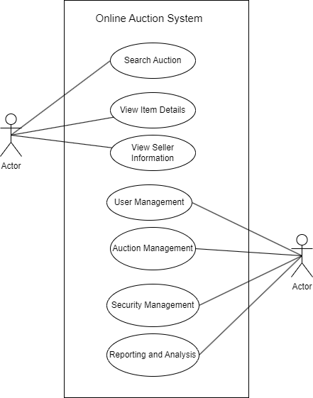

*Figure 2.1-2 Use case diagram for Online Auction System*

## Activity diagram and Swimlane diagram

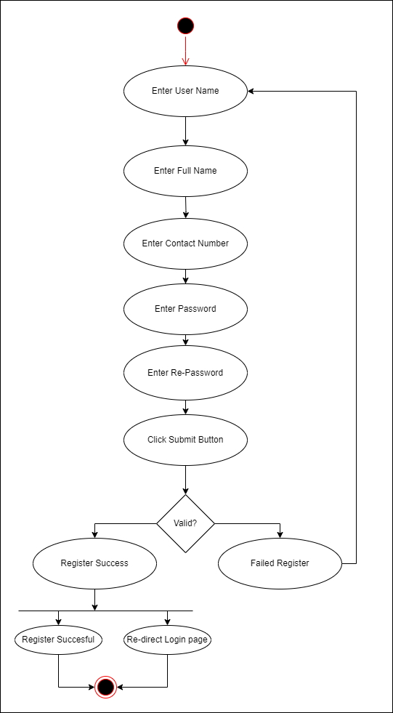

*Figure 2.2-1 Activity diagram for Register*

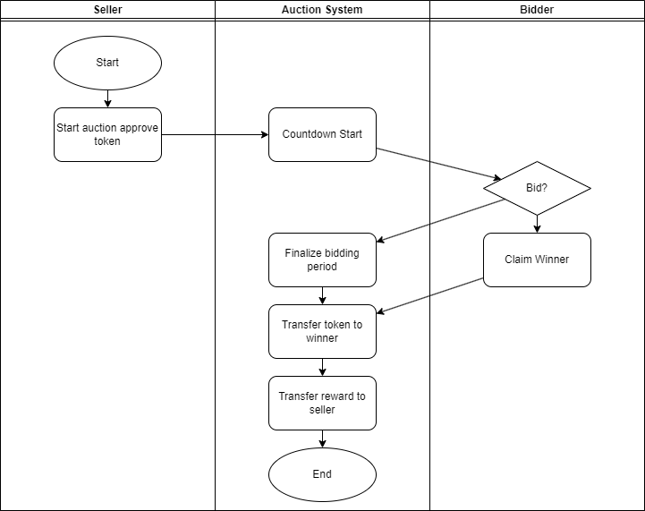

*Figure 2.2-2 Swimlane diagram for Auction Start*

## Sequence diagram

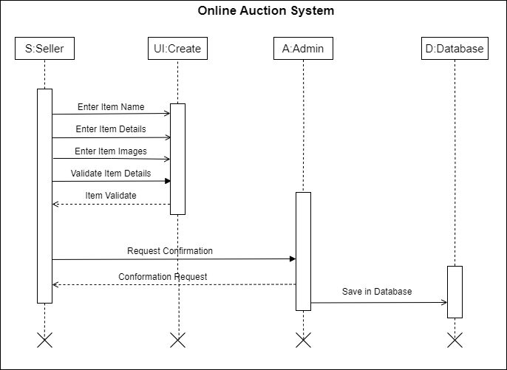

*Figure 2.3-1 Sequence diagram for Create Item*

## State diagram

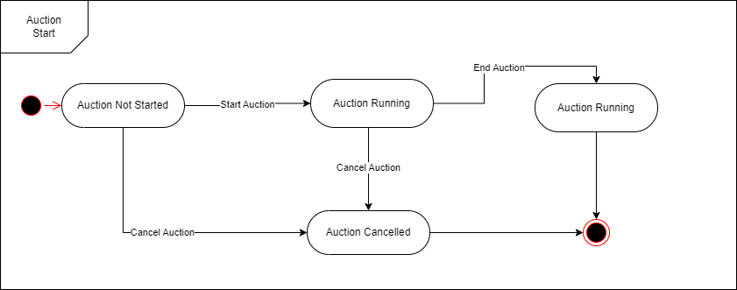

*Figure 2.4-1 State diagram for Auction Start*

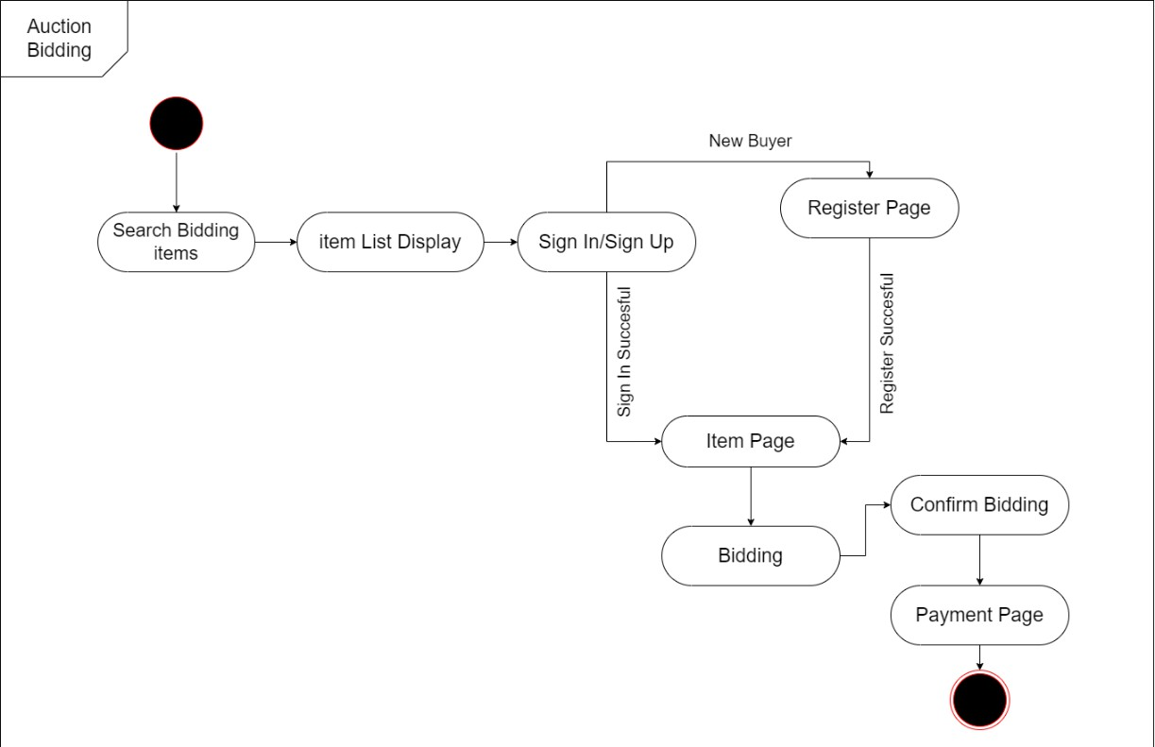

*Figure 2.4-2 State diagram for Auction Bidding*

## Class diagram

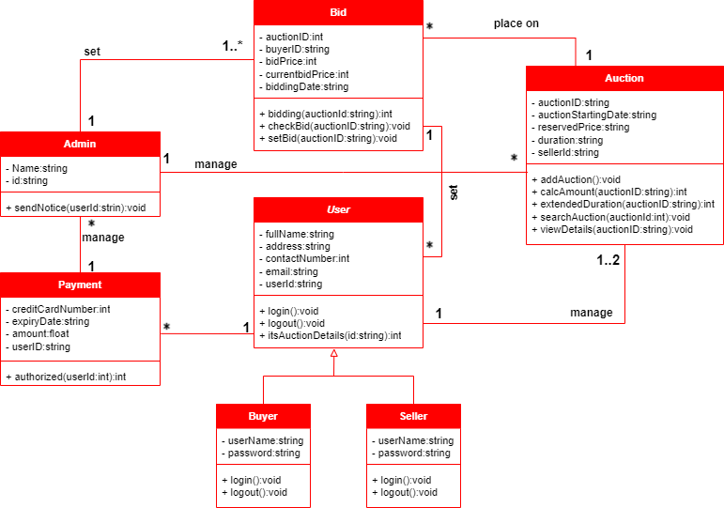

*Figure 2.5-1 Class diagram for Online Auction System*

## Data flow diagram

### Context diagram (level-0)

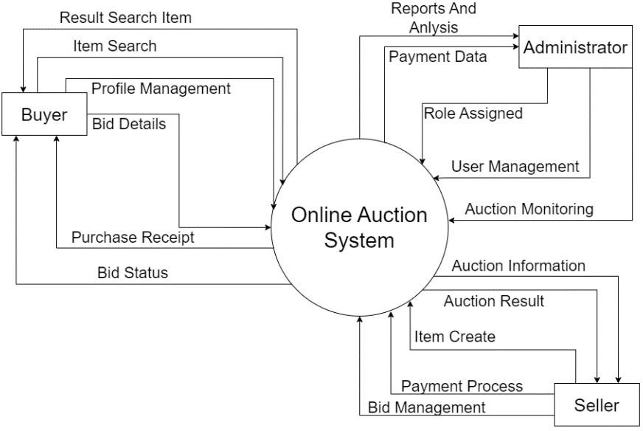

### DFD Level-1

*Figure 2.6-1 Context diagram for Online Auction System*

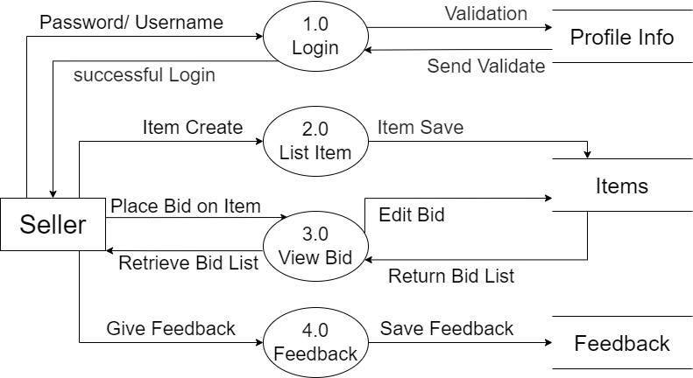

*Figure 2.6-2 DFD level-1 for Online Auction System*

# External interface requirement (Screens)

## Screen-1: Home screen

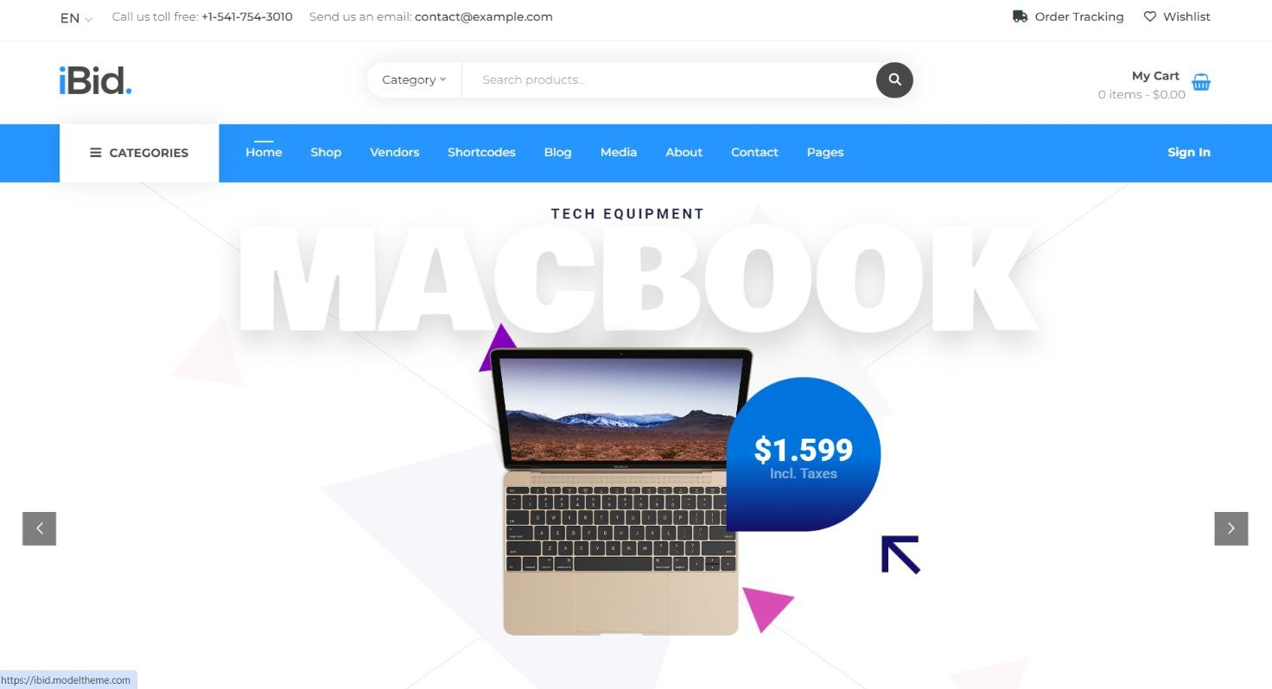

*Figure 3.1-1 Screen-1: Home Screen*

**Purpose:** The Home Screen aims to provide a seamless and engaging user experience, guiding users through the auction process with ease and efficiency.

*Table 3.1-1 Screen element of Home Screen*

|  |  |  |  |  |  |
| --- | --- | --- | --- | --- | --- |
| **Sr.** | **Screen Element** | **Input Type** | **O/M** | **1/N** | **Description** |
| **1** | Title | Text | M | 1 | Shows the site title "iBid." |
| **2** | Category | Text | M | 1 | Shows a dropdown menu to select categories of  products. |
| **3** | Search Item | Text | M | 1 | Allows users to search for items by entering item  names. |
| **4** | My Cart | Text | M | 1 | Displays items that the user wants to purchase. |
| **5** | Nav-bar | Link | M | 1 | Displays links to various pages like Home, Shop, Vendors, Shortcodes, Blog, Media, About,  Contact, and Pages. |
| **6** | Slider of Latest Ausction Item | Image | M | N | Shows a slider of the latest added auction items, currently displaying a MacBook with the price of  $1,599 including taxes. |

## Screen-2: Auction Item List

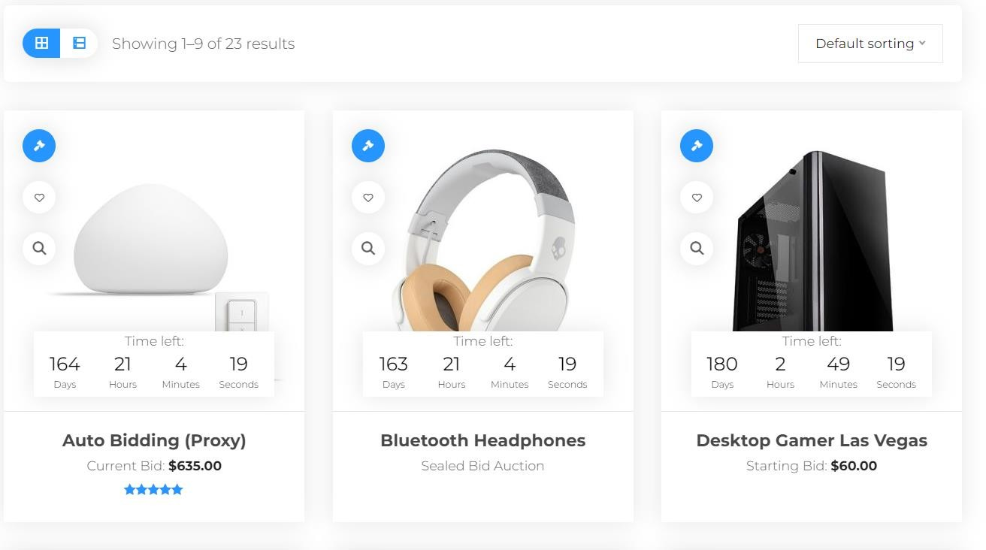

*Figure 3.2-1 Screen-2: Auction Item List*

**Purpose:** To display auction items in a user-friendly way, allowing users to browse, sort, and view item details easily. The page provides essential information such as item images, auction time, current bid prices, and quick view options to aid in efficient browsing and decision-making.

*Table 3.2-1 Screen element of Item List*

|  |  |  |  |  |  |
| --- | --- | --- | --- | --- | --- |
| **Sr.** | **Screen Element** | **Input Type** | **O/M** | **1/N** | **Description** |
| **1** | Grid -> List (List -  > Grid) | Buttons | M | 1 | Toggle between grid and list views for displaying items. |
| **2** | Default sorting | Button | M | 1 | Sort the list based on various criteria such as  alphabet, bid amount, and new/old items. |
| **3** | Item image | Image | M | N | Displays an image of the auction item. |
| **4** | Auction time left | Datetime | M | 1 | Shows the remaining time for the auction in a  countdown format. |
| **5** | Item current/starting  bid | Text | O | 1 | Displays the current bid price or the starting bid price in dollars. |
| **6** | Quick view | Button | M | 1 | Provides a quick view of the item details. |

## Screen-3: Item details

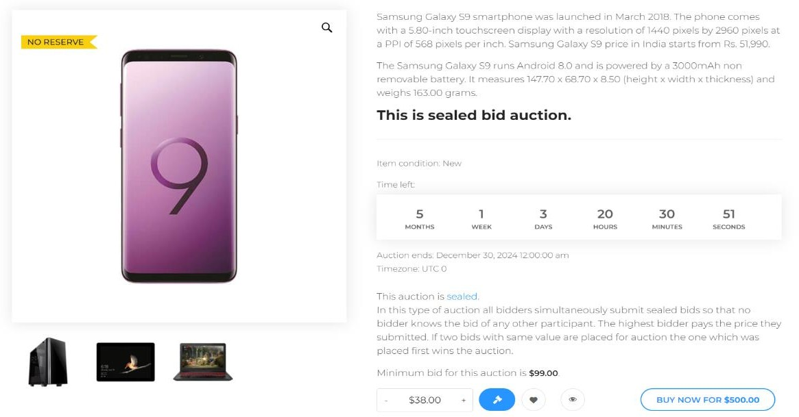

*Figure 3.3-1 Screen-3: Item Details*

**Purpose:** To display detailed information about a specific auction item, allowing users to view item specifications, auction details, and place bids. This page provides comprehensive information such as item images, descriptions, auction type, time left, minimum bid, and bidding options to facilitate informed decision-making for potential bidders.

*Table 3.3-1 Screen element of Item Details*

|  |  |  |  |  |  |
| --- | --- | --- | --- | --- | --- |
| **Sr.** | **Screen Element** | **Input Type** | **O/M** | **1/N** | **Description** |
| **1** | Item Image | Image | M | 1 | Displays the main image of the auction item. |
| **2** | Item Description | Text | M | 1 | Provides detailed information about the auction  item, including specifications and condition. |
| **3** | Auction Type | Text | M | 1 | Indicates the type of auction (e.g., sealed bid  auction). |
| **4** | Time Left | Datetime | M | 1 | Shows the remaining time for the auction in a  countdown format. |
| **5** | Auction End  Date | Datetime | M | 1 | Displays the date and time when the auction will  end. |
| **6** | Bid Amount | Textbox | M | 1 | Allows users to enter their bid amount. |
| **7** | Share | Button | O | 1 | Option to share the auction item. |
| **8** | Buy Now | Button | O | 1 | Allows users to buy the item immediately at a  specified price. |

## Screen-4: Store List

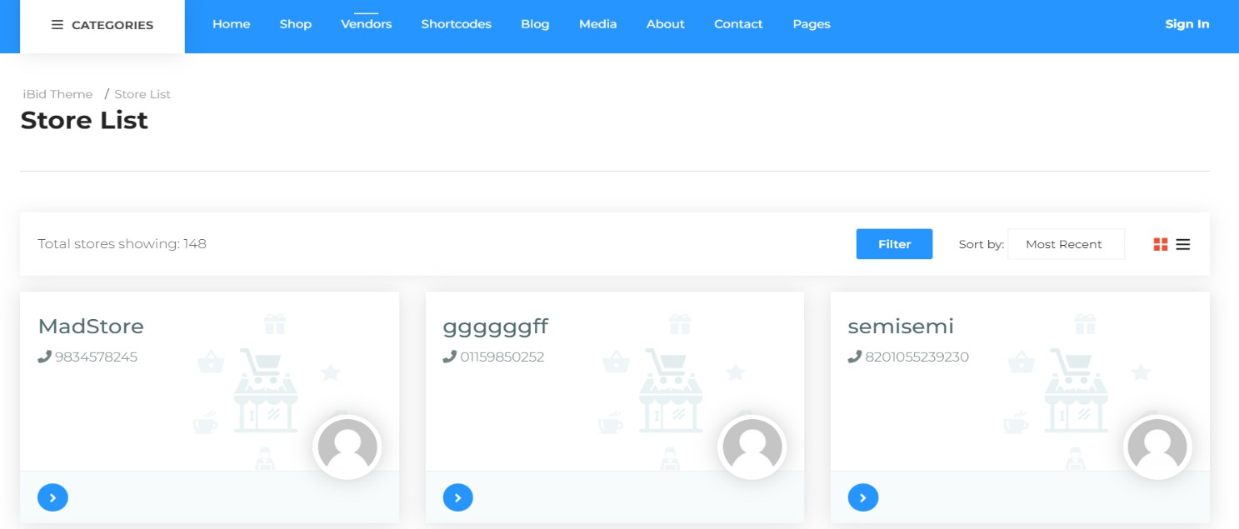

*Figure 3.4-1 Screen-4:Store List*

**Purpose:** The purpose of this screen is to display a list of stores available in the system. It allows users to view store details, filter the list, and sort the stores based on different criteria.

*Table 3.4-1 Screen element of Store List*

|  |  |  |  |  |  |
| --- | --- | --- | --- | --- | --- |
| **Sr.** | **Screen Element** | **Input Type** | **O/M** | **1/N** | **Description** |
| **1** | Store Name | Text | M | 1 | Displays the name of the store. |
| **2** | Store Contact | Text | M | 1 | Shows the contact number of the store. |
| **3** | Store Image | Image | O | 1 | Displays an image representing the store. |
| **4** | Filter Button | Button | M | 1 | Allows users to filter the list of stores based on  specific criteria.q |
| **5** | Sort Dropdown | Dropdown | M | 1 | Provides options to sort the store list (e.g., Most  Recent). |
| **6** | Navigation  Arrows | Button | O | 1 | Allows users to navigate through the store cards. |

## Screen-5: Categories Grid

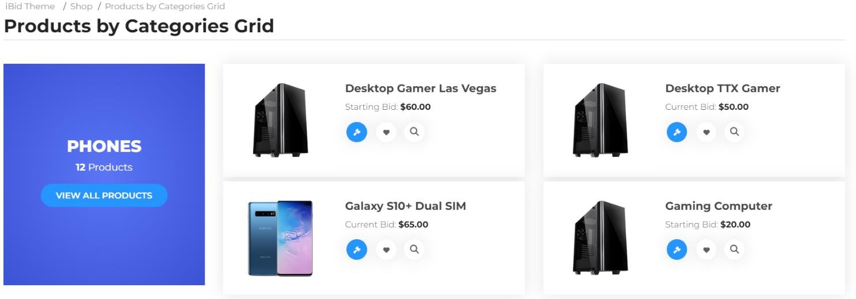

*Figure 3.4-1 Screen-5:Categories grid*

**Purpose:** This screen is Purpose to show Categories Wise Item.

*Table 3.4-1 Screen element of Categories grid*

|  |  |  |  |  |  |
| --- | --- | --- | --- | --- | --- |
| **Sr.** | **Screen Element** | **Input Type** | **O/M** | **1/N** | **Description** |
| **1** | Categories  Name | Text | M | 1 | Displays the name of the category (e.g.,  PHONES). |
| **2** | Category  Product Count | Text | M | 1 | Shows the number of products in the category. |
| **3** | View All  Products Button | Button | M | 1 | Displays the main image of the product. |
| **4** | Product Title | Text | M | N | Shows the title of the product. |
| **5** | View Details  Button | Button | O | N | Allows users to view detailed information about  the product. |

# Database design

## List of Tables

* Users
* Item
* Bids
* Categories
* Payments

*Table 4.1-1 Table: Users*

|  |  |  |  |  |
| --- | --- | --- | --- | --- |
| **Column** | **Data Type** | **Null** | **Keys & Constrains** | **Default Value & Description** |
| **UserID** | int | NN | PK (Auto Increment) |  |
| **UserName** | varchar(100) | NN |  |  |
| **Password** | varchar(50) | NN |  |  |
| **Email** | Varchar(50) | NN |  |  |
| **ContactNumber** | Int | NN |  |  |
| **Addresh** | Varchar(100) | AN |  |  |

*Table 4.1-2 Table: Item*

|  |  |  |  |  |
| --- | --- | --- | --- | --- |
| **Column** | **Data Type** | **Null** | **Keys & Constrains** | **Default Value & Description** |
| **ItemID** | int | NN | PK (Auto Increment) |  |
| **ItemName** | varchar(100) | NN |  |  |
| **Title** | varchar(50) | AN |  |  |
| **Description** | varchar(100) | NN |  |  |
| **StartingPrice** | int | NN |  |  |
| **StartDate** | DateTime | NN |  |  |
| **EndDate** | DateTime | AN |  |  |
| **CategoryID** | int | AN | FK | Referencing of Category  Table |

*Table 4.1-3 Table: Bids*

|  |  |  |  |  |
| --- | --- | --- | --- | --- |
| **Column** | **Data Type** | **Null** | **Keys & Constrains** | **Default Value & Description** |
| **BidID** | int | NN | PK (Auto Increment) |  |
| **ItemID** | int | NN | FK | Referencing of Item Table |
| **UserID** | int | NN | FK | Referencing of Users Table |
| **BidAmount** | int | NN |  |  |
| **BidStart** | DateTime | AN |  |  |

*Table 4.1-4 Table: Categories*

|  |  |  |  |  |
| --- | --- | --- | --- | --- |
| **Column** | **Data Type** | **Null** | **Keys & Constrains** | **Default Value & Description** |
| **CategoryID** | int | NN | PK (Auto Increment) |  |
| **CategoryName** | varchar(100) | NN |  |  |
| **Description** | varchar(100) | AN |  |  |

*Table 4.1-5 Table: Payments*

|  |  |  |  |  |
| --- | --- | --- | --- | --- |
| **Column** | **Data Type** | **Null** | **Keys & Constrains** | **Default Value & Description** |
| **PaymentID** | int | NN | PK (Auto Increment) |  |
| **UserID** | int | NN | FK | Referencing of Users Table |
| **ItemID** | int | NN | FK | Referencing of Item Table |
| **PaymentAmount** | int | NN |  |  |
| **PaymentDate** | DateTime | NN |  |  |
| **PaymentMethod** | varchra(50) | AN |  |  |

# Stories and Scenario

## Story-1: Create New Auction Listing

|  |  |  |
| --- | --- | --- |
| *Story #* ***S1*** | **:** | **As a** Seller**,**  **I want** to create a new auction listing  **So that** I can sell my items to the highest bidder. |
| **Priority** | **:** | High |
| **Estimate** | **:** | XL |
| **Reason** | **:** | Creating auction listings is fundamental to the operation of the auction system,  enabling sellers to offer their items to potential buyers. |

### Scenario# S1.1

|  |  |  |
| --- | --- | --- |
| *Scenario#* ***S1.1*** | **:** | Creating an Auction Listing with Valid Information |
| **Prerequisite** | **:** | The seller is logged into the auction system. |
| **Acceptance Criteria** | **:** | **Given:** The seller is navigated to the auction creation page. Valid item details, including title, description, starting bid, reserve price, and auction duration, are provided.  **When:**  The seller selects the "Create New Auction" option, And the seller enters valid item details,  The seller clicks the "Save" button to list the item for auction.  **Then:** The system successfully creates the auction listing, and the seller receives a confirmation message with the auction ID. |

### Scenario# S1.2

|  |  |  |
| --- | --- | --- |
| *Scenario#* ***S1.2*** | **:** | Creating an Auction Listing with Invalid Information |
| **Prerequisite** | **:** | The seller is logged into the auction system. |
| **Acceptance Criteria** | **:** | **Given:** The seller is on the auction creation page.  **When:** The seller selects the "Create New Auction" option, And the seller enters incomplete or incorrect item details, The seller clicks the "Save" button to list the item for auction.  **Then:** The system displays error messages for the incorrect or missing information, and the auction listing is not created. |

### Scenario# S1.3

|  |  |  |
| --- | --- | --- |
| *Scenario#* ***S1.3*** | **:** | Attempting to Create a Duplicate Auction Listing |
| **Prerequisite** | **:** | The seller is logged into the auction system, and the seller is on the  auction creation page. |
| **Acceptance Criteria** | **:** | **Given**: The item information, including title, description, and starting bid, is available, and the item with the same details is already listed for auction.  **When**: The seller clicks the “Create Auction” button and attempts to create  a listing with the same item details.  **Then**: The system prevents the creation of a duplicate listing and prompts  the seller to update or manage the existing auction. |

## Story-2: Search for Auctions

|  |  |  |
| --- | --- | --- |
| *Story #* ***S2*** | : | **As a** Buyer or Seller**,**  **I want** to search for auctions by item title, category, or keyword  **So that** I can quickly find or manage auctions of interest. |
| **Priority** | **:** | High |
| **Estimate** | **:** | M |
| **Reason** | **:** | Implementing search functionality is essential for enhancing the user experience, enabling buyers and sellers to efficiently discover or manage auction listings. |

## Story-3: Place a Bid

|  |  |  |
| --- | --- | --- |
| *Story #* ***S3*** | **:** | **As a** Buyer**,**  **I want** to place a bid on an auction item  **So that** I can compete to purchase the item. |
| **Priority** | **:** | High |
| **Estimate** | **:** | M |
| **Reason** | **:** | Bidding functionality is core to the auction system, allowing buyers to participate in auctions and compete for items. |

## Story-4: Manage Auction End Date

|  |  |  |
| --- | --- | --- |
| *Story #* ***S3*** | **:** | **As a** Seller**,**  **I want** to manage the end date of my auction  **So that I** can extend or shorten the auction period based on demand. |
| **Priority** | **:** | Medium |
| **Estimate** | **:** | M |
| **Reason** | **:** | Managing the auction end date is crucial for sellers who wish to optimize the  timing of their auctions based on market conditions. |

## Story-5: Generate a Report on Auction Activity

|  |  |  |
| --- | --- | --- |
| *Story #* ***S3*** | **:** | **As an** Administrator**,**  **I want** to generate reports on auction activity  **So that** I can analyze trends and make informed decisions about the platform**.** |
| **Priority** | **:** | Medium |
| **Estimate** | **:** | L |
| **Reason** | **:** | Reporting functionality is important for tracking the performance of the auction platform and making data-driven improvements. |

# Test cases

|  |  |  |  |
| --- | --- | --- | --- |
| **Project Name:** | **Auctino System** | **Test Designed by:** | **Himanshu Parmar** |
| **Module Name:** | **Placed Item** | **Test Designed date:** | 23-08-2024 |
| **Release Version:** | **1.0** | **Test Executed by:** | **R. B. Gondaliya** |
|  |  | **Test Execution date:** | 15-01-2023 |

|  |  |  |  |  |
| --- | --- | --- | --- | --- |
| **Pre-condition**: **Web application should be accessible** | | | | |
| **Test Case ID** | **Test Title** | **Test Type** | **Description** | **Test Case ID** |
| **TC_001** | Access "Place Item in Auction" Page | Functional | Verify that the user can access the "Place Item in Auction" page after  logging in | TC_001 |
| **TC_002** | Place Item in Auction with Valid Details | Functional | Verify that the user can successfully place an item in the auction with all  valid details | TC_002 |
| **TC_003** | Place Item in Auction with Missing  Mandatory Fields | Functional | Verify that the system prevents placing an item in the auction when  mandatory fields are missing | TC_003 |
| **TC_004** | Verify Auction Listing After Item Placement | Functional | Verify that the Item Details Should  be placed successfully in the auction. | TC_004 |

|  |  |
| --- | --- |
| Test Case Title | Access "Place Item in Auction" Page |
| Test Type | Functional |
| Test Priority | High |
| Pre-condition | User should be logged into the web application |

|  |  |  |  |  |  |  |  |
| --- | --- | --- | --- | --- | --- | --- | --- |
| Test Step | Test Case Description | Expected Result | Actual Result | Status | Comment | Data | BUG ID |
| 1 | Navigate to "Place Item in Auction" page via the  dashboard | "Place Item in Auction" page should be accessible | "Place Item in Auction" page accessed  successfully | Pass |  |  |  |
| 2 | Verify that all input fields (e.g., item title, description, starting bid)  are visible | All input fields should be  visible and editable | All input  fields are  visible and editable | Pass |  |  |  |
| 3 | Verify the presence of the "Upload Image" option on the page. | The "Upload Image" option should be  visible and functional, allowing users  to upload an | The "Upload Image" option was  visible and functional. | pass |  |  |  |

|  |  |  |  |  |  |  |  |
| --- | --- | --- | --- | --- | --- | --- | --- |
|  |  | image of the item. |  |  |  |  |  |
| 4 | Verify the presence of the "Submit" button on  the page. | The "Submit" button should be visible and clickable. | The "Submit" button was  visible and clickable. | Pass |  |  |  |

|  |  |
| --- | --- |
| Test Case Title | Place Item in Auction with Valid Details |
| Test Type | Functional |
| Test Priority | High |
| Pre-condition | User should be logged into the web application |

|  |  |  |  |  |  |  |  |
| --- | --- | --- | --- | --- | --- | --- | --- |
| Test  Step | Test Case  Description | Expected  Result | Actual Result | Status | Comment | Data | Bug ID |
| 1 | Enter valid item title in the title field | The title field should  accept the input | Title input accepted | Pass |  | Title: "Vintage Watch" |  |
| 2 | Enter valid item description in the  description  field | The description field should accept the  input | Description input accepted | Pass |  | Description: "A classic vintage watch in good condition" |  |
| 3 | Enter valid starting bid amount | The starting bid field should accept the  input | Starting bid input accepted | Pass |  | Starting bid: $50 |  |
| 4 | Enter valid auction end date and time | The date  and time fields should accept input, and the end date  should be | Date and  time input accepted | Pass |  | End date: 2024-  11-01 18:00 |  |

|  |  |  |  |  |  |  |  |
| --- | --- | --- | --- | --- | --- | --- | --- |
|  |  | in the  future |  |  |  |  |  |
| 5 | Upload item image | The image upload field should accept the image file | Image uploaded successfully | Pass |  | Image:  “watch.png” |  |
| 6 | Click on the "Submit" button | The item should be placed in the auction, and a  success message should appear | Item placed in auction successfully, and success message displayed | Pass |  |  |  |

|  |  |
| --- | --- |
| Test Case Title | Place Item in Auction with Missing Mandatory Fields |
| Test Type | Functional |
| Test Priority | Medium |
| Pre-condition | Web application should be accessible |

|  |  |  |  |  |  |  |  |
| --- | --- | --- | --- | --- | --- | --- | --- |
| Test Step | Test Case Description | Expected Result | Actual Result | Status | Comment | Data | Bug ID |
| 1 | Leave the | The | Error | Pass |  |  |  |
|  | item title | system | message |  |
|  | field | should | displayed, |  |
|  | empty | prevent | and |  |
|  |  | submissio | submission |  |
|  |  | n and | prevented |  |
|  |  | display an |  |  |
|  |  | error |  |  |
|  |  | message |  |  |
| 2 | Leave the | The | Error | Pass |  |  |  |
|  | descriptio | system | message |  |
|  | n field | should | displayed, |  |
|  | empty | prevent | and |  |
|  |  | submissio | submission |  |
|  |  | n and | prevented |  |
|  |  | display an |  |  |
|  |  | error |  |  |
|  |  | message |  |  |

|  |  |  |  |  |  |  |  |
| --- | --- | --- | --- | --- | --- | --- | --- |
| 3 | Leave the starting bid field empty | The system should prevent submissio n and display an  error message | Error message displayed, and submission prevented | Pass |  |  |  |
| 4 | Click on the "Submit" button with missing mandatory fields | The item should not be placed in the auction, and appropria te error messages should be  shown | Submission prevented, and error messages displayed | Pass |  |  |  |

|  |  |
| --- | --- |
| Test Case Title | Verify Auction Listing After Item Placement |
| Test Type | Functional |
| Test Priority | High |
| Pre-condition | An item should be placed successfully in the auction. |

|  |  |  |  |  |  |  |  |
| --- | --- | --- | --- | --- | --- | --- | --- |
| Test Step | Test Case Description | Expected Result | Actual Result | Status | Comment | Data | Bug ID |
| 1 | Navigate  to the | The  placed | Item visible  in the | Pass |  | Item title: "Vintage Watch" |  |
|  | auction | item | auction list |  |  |
|  | listing | should be |  |  |  |
|  | page. | visible in |  |  |  |
|  |  | the |  |  |  |
|  |  | auction |  |  |  |
|  |  | list. |  |  |  |
| 2 | Verify the | The item | The item | Pass |  | Title: "Vintage Watch" |  |
|  | details of | title | title |  |  |
|  | the placed | should | matches |  |  |
|  | item in the | match | the input |  |  |
|  | auction | the title | provided |  |  |
|  | list, | provided | during |  |  |
|  | including | during | placement. |  |  |
|  | the item | item |  |  |  |
|  | title. |  |  |  |  |

|  |  |  |  |  |  |  |  |
| --- | --- | --- | --- | --- | --- | --- | --- |
|  |  | placemen t. |  |  |  |  |  |
| 3 | Verify the | The item | The item | Pass |  | Description: "A classic vintage watch in good condition" |  |
|  | item | descriptio | description |  |
|  | descriptio | n should | matches |  |
|  | n in the | match | the input |  |
|  | auction | the | provided |  |
|  | list. | descriptio | during |  |
|  |  | n | placement. |  |
|  |  | provided |  |  |
|  |  | during |  |  |
|  |  | item |  |  |
|  |  | placemen |  |  |
|  |  | t. |  |  |
| 4 | Verify the | The | The starting | Pass |  | Starting Bid: $50 |  |
|  | starting | starting | bid amount |  |  |
|  | bid | bid | matches |  |  |
|  | amount in | amount | the input |  |  |
|  | the | should | provided |  |  |
|  | auction | match the | during |  |  |
|  | list. | value | placement. |  |  |
|  |  | provided |  |  |  |
|  |  | during |  |  |  |
|  |  | item |  |  |  |
|  |  | placemen |  |  |  |
|  |  | t. |  |  |  |
| 5 | Check for | There | No errors | Pass |  |  |  |
|  | any error | should be | found, and |  |
|  | messages | no error | all details |  |
|  | or | messages | are |  |
|  | discrepanc | , and all | accurate. |  |
|  | ies in the | details |  |  |
|  | auction | should be |  |  |
|  | listing | accurate |  |  |
|  | page. | as per the |  |  |
|  |  | item |  |  |
|  |  | placemen |  |  |
|  |  | t. |  |  |

# References

* <http://www.w3schools.com/html/html_intro.asp>
* https://[www.w3schools.com/php/default.asp](http://www.w3schools.com/php/default.asp)
* https://[www.javatpoint.com/uml](http://www.javatpoint.com/uml)